
Maize Analytics

Full Info Page Quick Reference

MAIZE
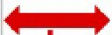
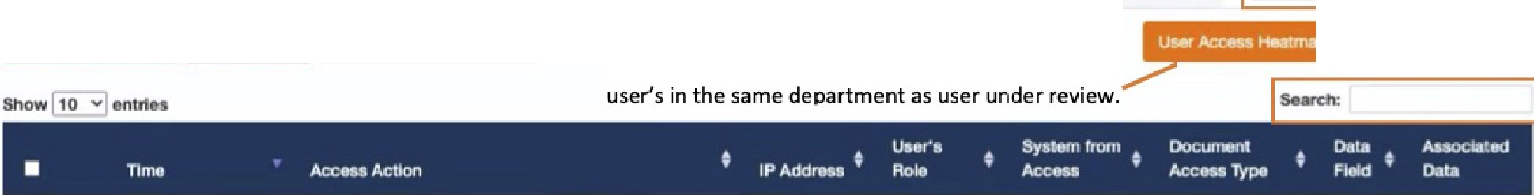
TANALYTICS
li
The Full Info page provides additional details about the patient, user, and their relationship. From the Search
page click the C, icon to the left of the access to review.
Full lnformation Page
Patient and User lnformation tables display current
& historical values. Add notes to User information.
Copies Full Info Page
URL to Clipboard Download PDF Report
Click on the "i" lcons to view.\.-­
/
Patlent: ELYSE WILLIAMs<i)
Click ID to view All
P0002777
VIP Star is displayed if Patient is a VIP. Orange Explanation Point displayed if User is on the Watch
List. Hover over to see VIP or Watch List Category.
I
User. DONALD MOOR@
Click ID to view All
Wi ·iM Mf-#*-·HM
Access to Patient
EII000818 --
Access bv User
J2 BROOKWOOD OR, BRATTUBORO.
vr 301
150 BRIO- HILL RO, ESSE)( TOWN.
vr05452
-
lll lll NoDOB/Młl/llbl&
Ili
BI
No ancountlN 06płlt1ment lnlormatlon
Title displayed if
NEUROLOG -
User's Department
·NA-
patient is an employee
1!11
NoOVt
User's Title
o
Red icon displayed if user and patient are neighbors. Click icon to view mapping.
Click to view Explanation details
Each TAB provides specific information about the patient and user under review. Click to view.7
Filter data displayed in TABS by modifying date range or Adding Search Terms
Acc-. Log EMR Encounter Info Patiem Ołagno111 Hłwtory V1suauze PatJeni llmelłne UMI' Behavtor 5ufflnary lnvwtJg.atk>nHłsto,y
F@h@}\ilil:#i\iH\ii U-Mar<,wopmto•
Click to view a heatmap of all Access Actions used by
- 1IJIIW2019 • IMlll/2020
. F·-ii+··i..lj.fi

,6 Manuał Explanationo o
Full Info Page Quick Reference

o 2020-05·13 00:00:00 | RESULTS CREATEO | 76.124 11.208 | NEUROLOGY | EPIC | KINGDOM  HOSPITAL
o 2020-05•13 00,00,00 | ME()!A.VIEWEO | 76 124 11.208 | NEUROLOGY | MEOITECH | KINGDOM  HOSPITAL | e
o 2020-05-13 00:00:00 | \/ISlTS \/IEWED | 76 12411.208 | NEURO\OGY | EPIC | KINGDOM  HOSPITAL | e
o 2020"°5·13 00:00:00 | ORDER UPDATED | 76.124 11.208 | NEUROLOGY | AL.1.SCRIPTS | KINGDOM
 |  |  |  |  | HOSPrTAL
o 2020-05-13 00:00,00 | ADMISSION COMMENTS SUBCOMPONENT ACCESSEO FOR PATIENT. | 76.124 I 1.208 | NEUROLOGY | AL.1.SCRIPTS | KINGDOM  HOSPITAL | e
o 2020-05•13 00:00:00 | ALERTS \/IEWED | 76.124 11.208 | NEUROLOGY | AL.1.SCRIPTS | KINGDOM
 |  |  |  |  | HOSPITAL
o 2020-05·13 00,00:00 | CHART SEARCH RESULT HOI/ER SUBBLE VIEWED | 76.124.1 f.208 | NEUROLOGY | AL.1.SCRIPTS | KINGDOM
 |  |  |  |  | HOSPITAL

Sl1cWTig 1 10 7 or 7 .,,,.....
IN\5$}f@)\\IF@!Hl/i IU-Mar.Appropna10• --Click toUNDO All orSelected
Accesses as Appropriate
Prov<lul Nex1

Click to Mark All or Selected Accesses as
Appropriate or to Add to an lnvestigation Download Accesses to CSV

© Maize Analytics 1.04.37.1 info@maizeanalytics.com Phone 615.997.0101 x 2 Duplication or distribution of this dDcument without Maize Analytics' expressed consent is prohibited.

